Now follow the web installer steps as per below given screen shots.
Step 3.1: Just click Next.
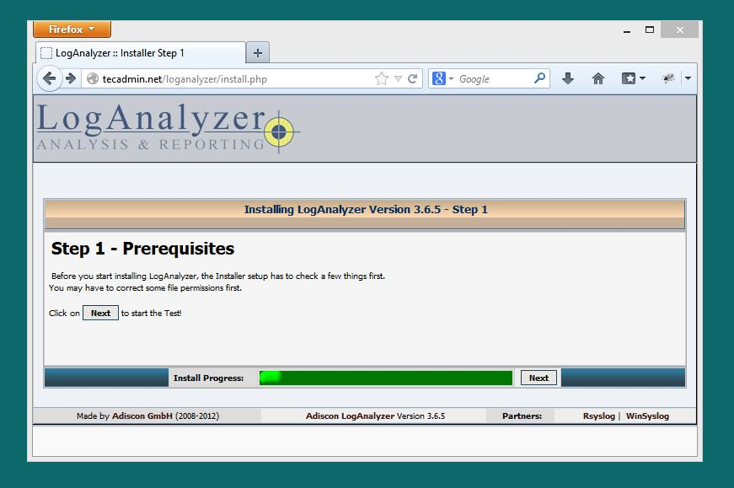
Step 3.2: Make sure config.php is writable and click Next.
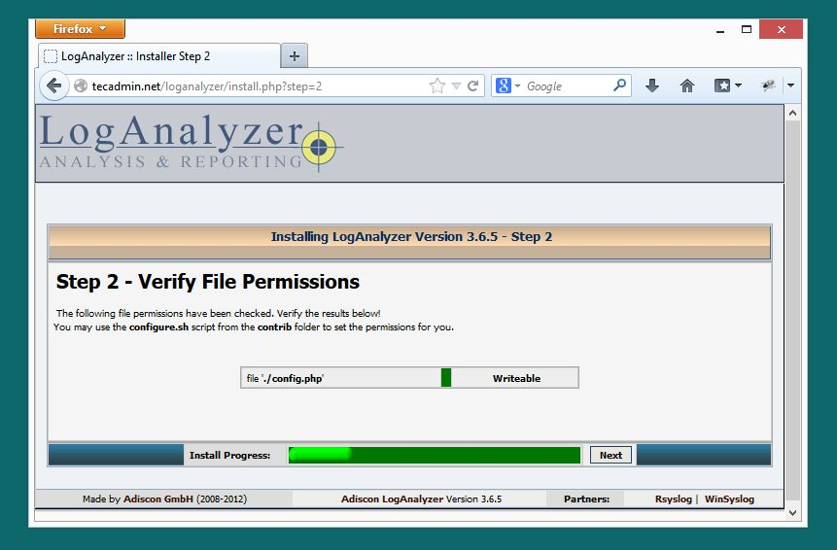

Step 3.3: Fill the database details for loganalyzer, we can also use same database used for Rsyslog and click Next.
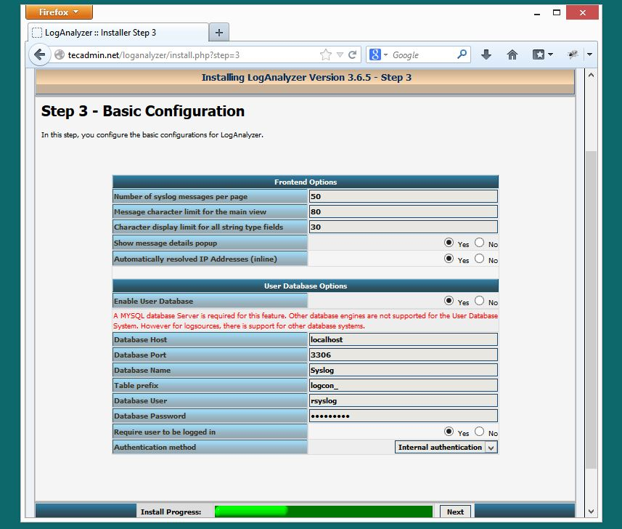

Step 3.4: In this step installer will create database table, if tables already found, you will get an warning of data overwritten. We just need to click Next.
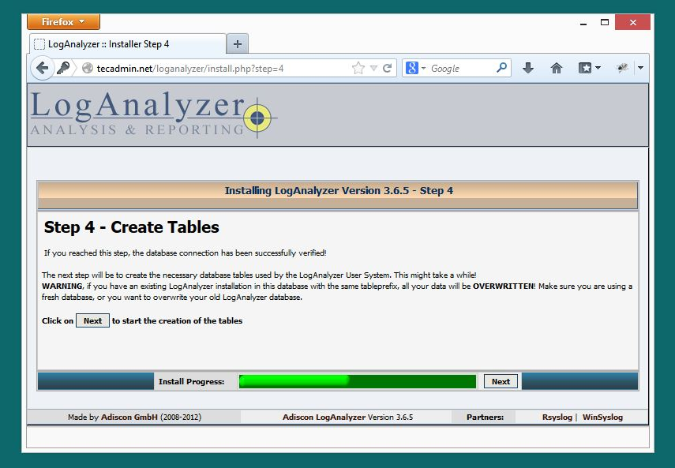
Step 3.5: This screen will show the result of table creation’s. Just click Next
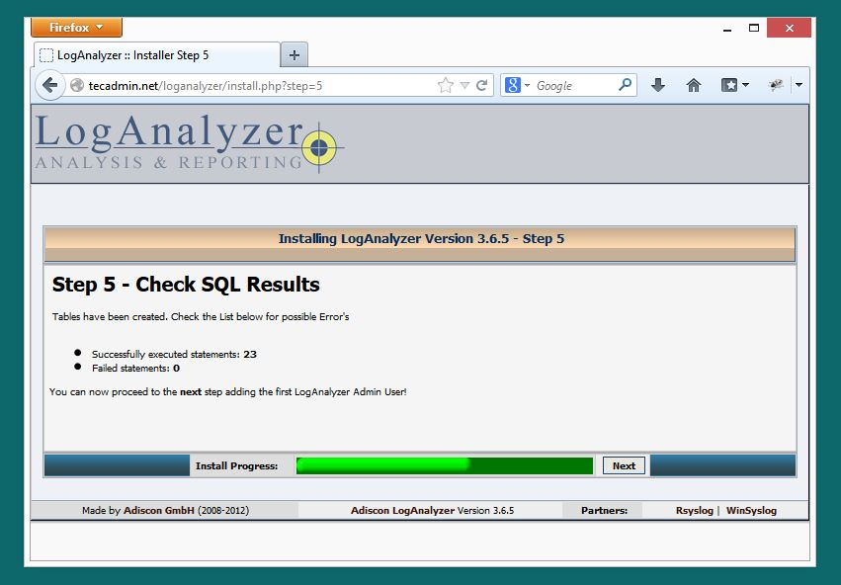

Step 3.6: Create an Administrator account and click Next.
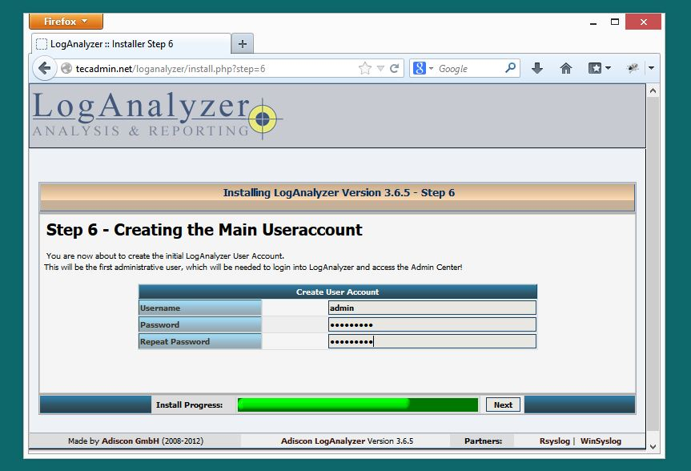
Step 3.7: Fill the Rsyslog database details and click Next.
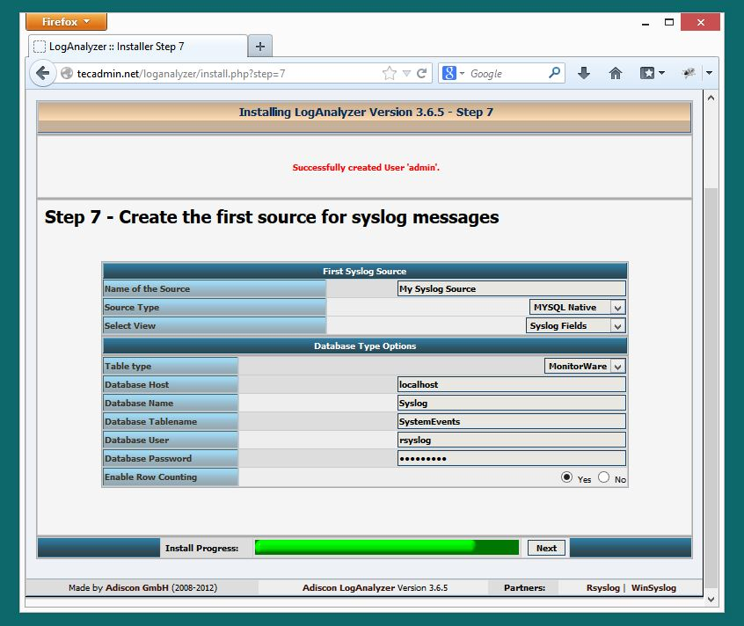
Step 3.8: LogAnalyzer installation has been completed. We just need to click Finish.
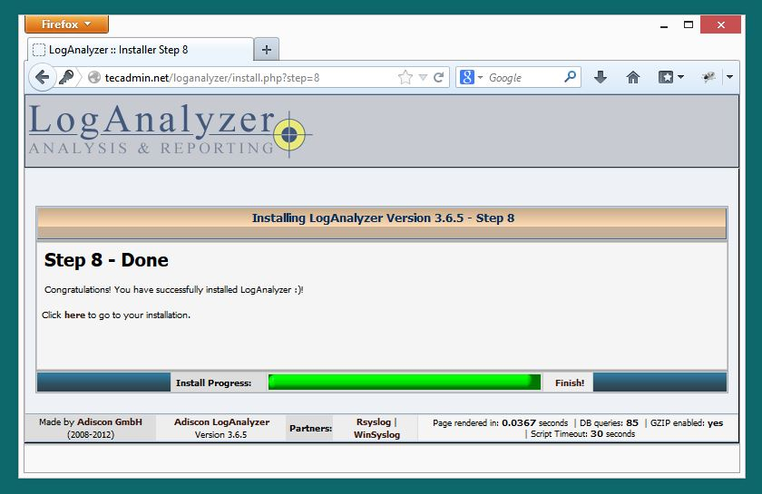
Step 3.9: Login to LogAnalyzer using Administrator credentials created in Step 3.6.
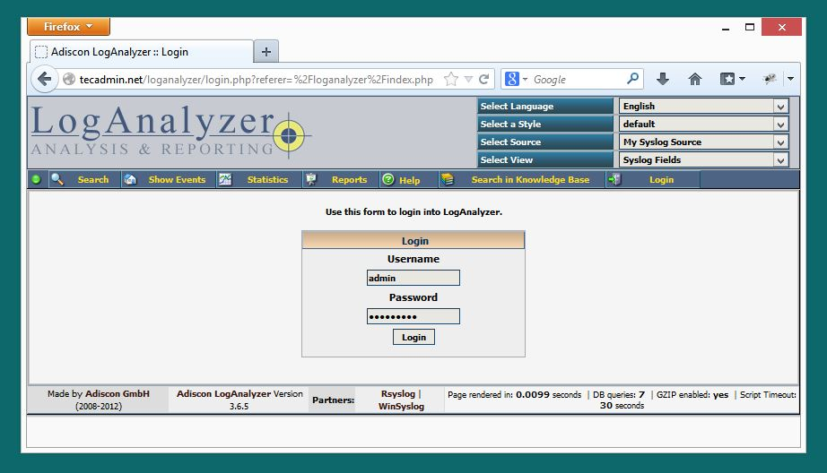

Congratulation’s! on successful configuration of LogAnalyzer with Rsyslog MySQL database. Read other article to configure Rsyslog to collect logs on central server. So we can monitor all server logs at on place using LogAnalyzer.

LOG AGENT:
https://kb.op5.com/display/DOC/Windows+SyslogAgent#WindowsSyslogAgent-DownloadandInstallation

https://www.op5.com/download/archives/category/agents/windows-syslog-agent/

